Title

Research Question

Subject

Word Count

Table of Contents

Topic 3

Experiment question 3

Hypothesis 3

Experiment 3

Theory 3

Formula 4

Sources of Error 5

# Introduction

## Theory

### Archimedes’ principle

Research of the buoyancy force begun early in the human history. Greek physicist Archimedes have started his investigation in this topic back in 250 BCE. In his work *On Floating Bodies*, Archimedes explains what happens when a solid “heavier” that a liquid is placed in a liquid, and what happens when as solid “lighter” than the liquid is placed within it.[1] Archimedes describes that when the “heavier” solid is placed in the liquid, it will sink to the bottom, where as the “lighter” liquid will displace an amount of the fluid that adds up to its own weight.

The first part of the principle is obvious, as the fluid under the solid will experience less gravitational force, and the solid which experiences more gravitational force will use part of the energy generated by the force to move the liquid out of its way.

To demonstrate the second part of the principle (placing the “lighter” solid into the liquid). Suppose there exists solid A being heavier than a liquid, a liquid and solid B being lighter than the liquid, all with the same volume V. Also let $(G+H)$ represent the weight of solid A, $G$ represent the weight of the liquid and $(G-H)$ to represent the weight of solid B. Under these assumptions, when mixing solid A and solid B together completely, they would have a combined mass of $G+H+G-H=2G$, and a volume of $2V$. The density of the newly made solid will become $\frac{2G}{2V}=G/V$, which is the same as the density of the liquid. Since the newly made solid and the liquid have the same density, the new solid will remain stationary in the liquid..

Archimedes realized that the force pulling on solid A to sink down must be the same to the force which solid B experiences to push itself up in the liquid.

Further more, when a solid is placed in water, it rises the surface of the water.

### C:\Users\The Leo\Pictures\Physics EE\forces.pngWater Pressure Interpretation

By placing an object in a liquid, it will experience pressure force from all directions. When the liquid is stationary and does not contain any flow, the pressure form to sides of the object would be the same. However, the pressure from the top and bottom of the object would be different. This is because the bottom has a greater distance from the surface of the medium which the object is surrounded by, thus it has a larger volume.

## Topic

I will be looking into buoyancy force, and trying to find the relationship between buoyancy force, the weight of an object, the density of the object and the density of the medium which the object is in.

### Experiment question

How will the change in density of the medium which an aluminum weight changes the gravitation force acting on the weight.

### Hypothesis

If the density of the medium is increased then the force due to gravity acting on the weight will decrease, because with a higher density but with the weight having a constant volume, more weight of the medium is displaced due to the weight, thus decreasing the force acting on the weight.

### Formula

In a resting fluid, the hydrostatic pressure is determined from the fallowing formula:

$$p= ρgl+ p_{a}$$

Where:

* $P$ is the hydrostatic pressure ($Pa$)
* $ρ$ is the density of the medium surrounding the point of measurement ($kgm^{-3}$)
* $g$ is the gravitational acceleration ($ms^{-2}$)
* $l$ is the distance from the point of measurement to the top of the medium parallel to the direction of gravity ($m$)
* $p_{a}$ is the atmospheric pressure

Thus, the difference in pressure between the top and the bottom can be calculated by subtracting the distances:

$$∆p=p_{1}-p_{2} \\ =\left(ρgl_{1}+ p_{a}\right)-\left(ρgl_{2}+ p_{a}\right) \\ = ρg×\left(l_{1}-l_{2}\right) \\ =ρgh$$

Where:

* $l_{1}$ is the distance from the top of the object to the top of the medium parallel to the direction of gravity ($m)$
* $l_{2}$ is the distance from the bottom of the object to the top of the medium parallel to the direction of gravity ($m$)
* $h$ is the height of the object, which is also the distance between $l_{1}$ and $l_{2}$

Since the buoyancy force is the resultant force from the difference in pressure, it can be calculated using this formula:

$$F=pA \\ =ρghA \\ =ρgv \\ =mg$$

Where:

* $F$ is the buoyancy force
* $A$ is the area which exerts the force due to the pressure. (base area)
* $v$ is the volume of the solid, simplified from $hA$ (volume = base area × height)
* $m$ is the mass of the medium displaced, simplified from $ρv$ (mass = density × volume)

This makes sense as the medium displaced would want to return to its equilibrium position, which is where the object is. Thus, the gravitation force acting on the medium will be transferred to buoyancy force trying to push the object away in attempt to restore its equilibrium.

## Experiment

### Set-up

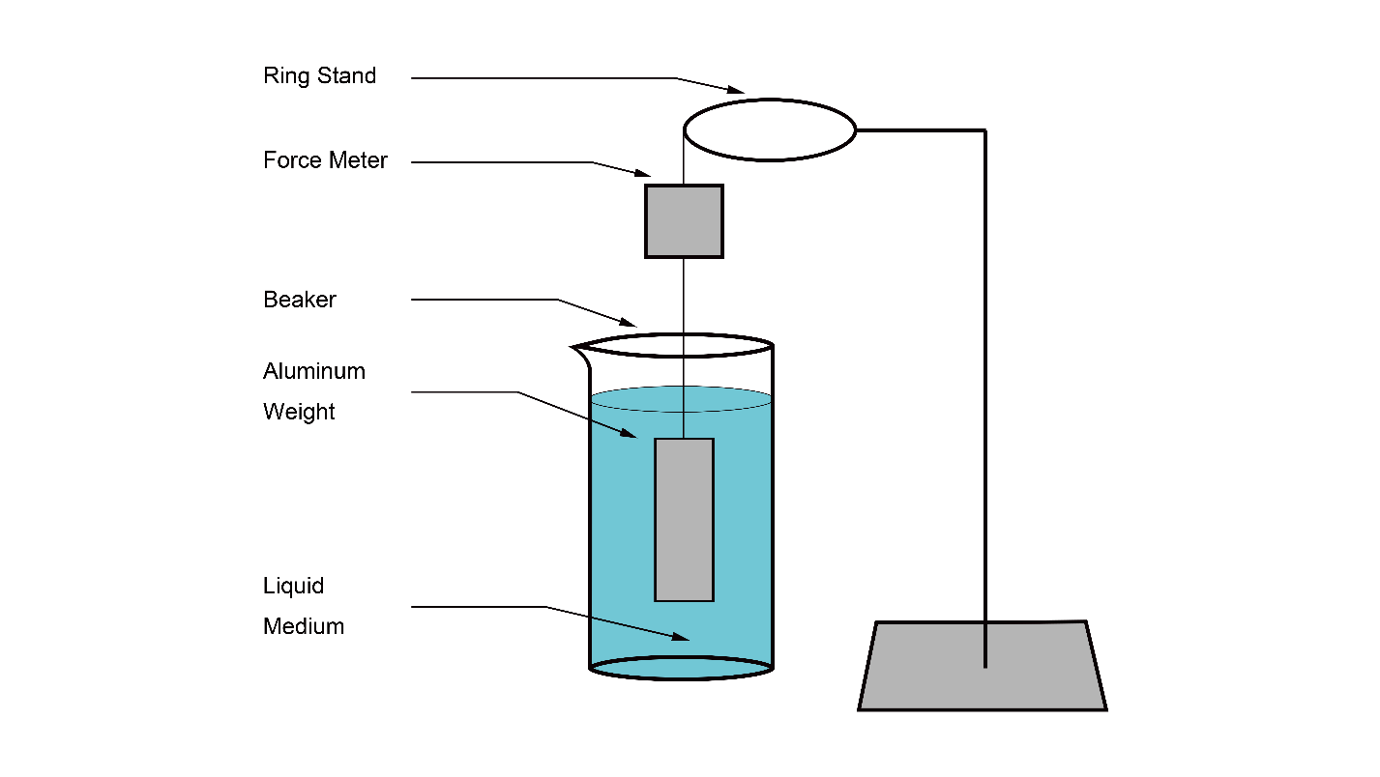

Note: The liquid medium will be changed to different solutions of different densities. For instance, sugar water solution and alcohol.

### Material list

Glycerine – 300ml

Tap water – 300ml

Methyl – 300ml

Ring Stand - 1

Ring Clamp - 1

Force Meter - 1

String (25cm) - 1

Aluminum weight (0.06kg) - 1

Beaker (250ml) - 3

Graduated cylinder(100ml) - 1

Electronic scale - 1

### Procedure

1. Mix 120ml of glycerine with 80ml of tap water from graduated cylinder to a beaker
2. Mix 70ml of methyl with 130 ml of tap water from graduated cylinder to a beaker
3. Connect the aluminum weight, force meter and the ring clamp with a string
4. Pour 200 ml of glycerine into a beaker
5. Submerge the aluminum weight
6. Record the weight from the force meter
7. Pour 100ml of glycerine into the graduated cylinder
8. Measure its weight
9. Clean the beaker and the graduated cylinder with water
10. Repeat step 4 to 9 with tap water, glycerine water solution, methyl, methyl water solution

### Weight of Aluminum weight (N) when placed into mediums of different densities (g/100ml)

|  |  |  |  |  |  |  |  |
| --- | --- | --- | --- | --- | --- | --- | --- |
| Medium | Density | Trial 1 | Trial 2 | Trial 3 | Trial 4 | Trial 5 | Average |
| C3H8O3 | 122.62 | 0.301 | 0.298 | 0.307 | 0.294 | 0.393 | 0.301 |
| C3H8O3 + H2O | 112.31 | 0.319 | 0.330 | 0.315 | 0.326 | 0.322 | 0.322 |
| H2O | 97.95 | 0.377 | 0.369 | 0.365 | 0.376 | 0.378 | 0.373 |
| CH3OH + H2O | 90.71 | 0.383 | 0.387 | 0.395 | 0.392 | 0.385 | 0.388 |
| CH3OH | 77.60 | 0.421 | 0.425 | 0.418 | 0.413 | 0.427 | 0.421 |

Note: The Average is calculated by adding the values of trial 1 ~ 5 and dividing the sum by 5

$$w_{average}=(w_{1}+w_{2}+w_{3}+w_{4}+w_{5})÷5$$

## Sources of Error

|  |  |  |
| --- | --- | --- |
| Source of error | Significance | actions to avoid |
| Shape of the weight | The top and bottom must be a flat surface perpendicular to the direction of gravity for my model to work | Use a cylindrical weight that have same flat surface on the bottom and the bottom, and a hook at the top to keep it balanced. |
| Density of the liquid | If the density of the liquid is significantly higher than the weight, then the weight might float which causes the force measured to become 0 | Use liquids that have less density than the weight |
| Difference between the density of the liquid and the weight | If the difference between the density of the liquid and the weight is too big, then the change in force will be very small, thus causing the measurement to be inaccurate | Match the density of the liquid so that they are similar but does not have a overly big difference. |
| Movement of the liquid | With movement with the liquid, there will be more pressure acting on the sides of the weight, changing its net force. | The liquid must be stationary. This can be achieved by waiting a certain time after putting the weight in the water before taking the measurement of the force. |

1. Back in the time of Archimedes, the concept of density has not been popularized. However, as Archimedes is investigating buoyancy force, which is directly related to the density, he uses the words “lighter” and “heavier” to describe objects with less or more density.